**NEWS CLIPPINGS USER MANUAL**

1. **SETTING UP WEB PART**

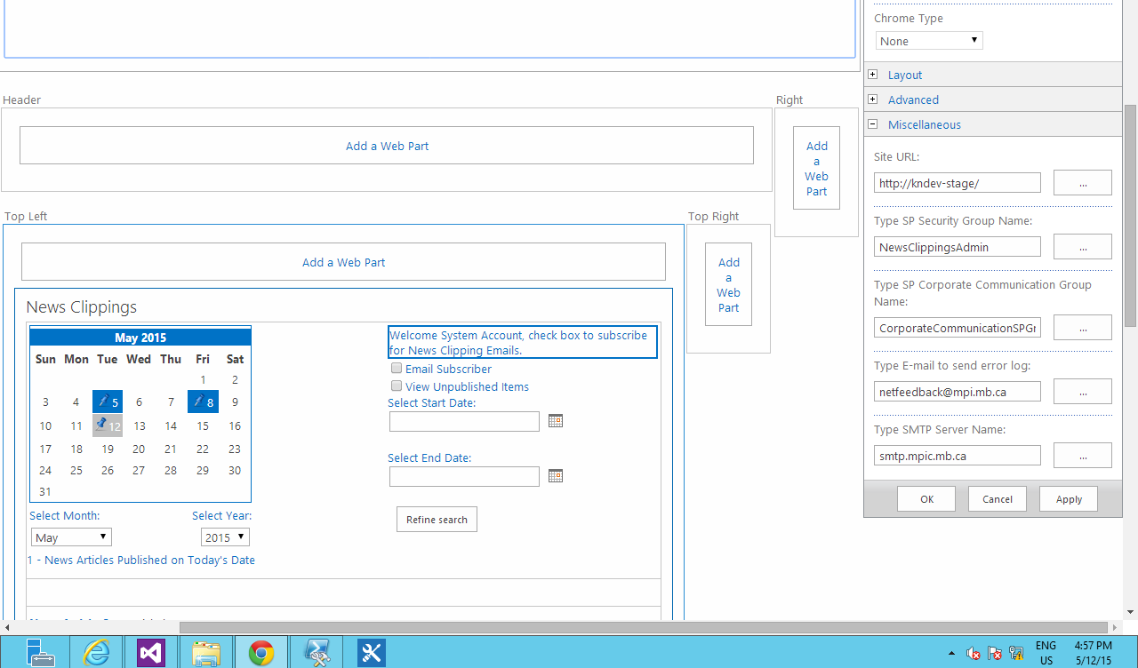

1. **SEARCH**

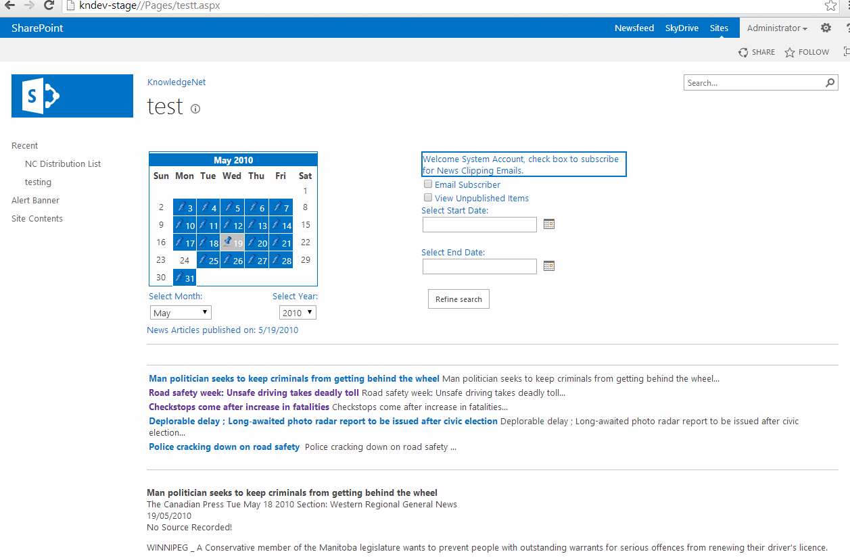

1. **ADDING NEW CLIPPING**

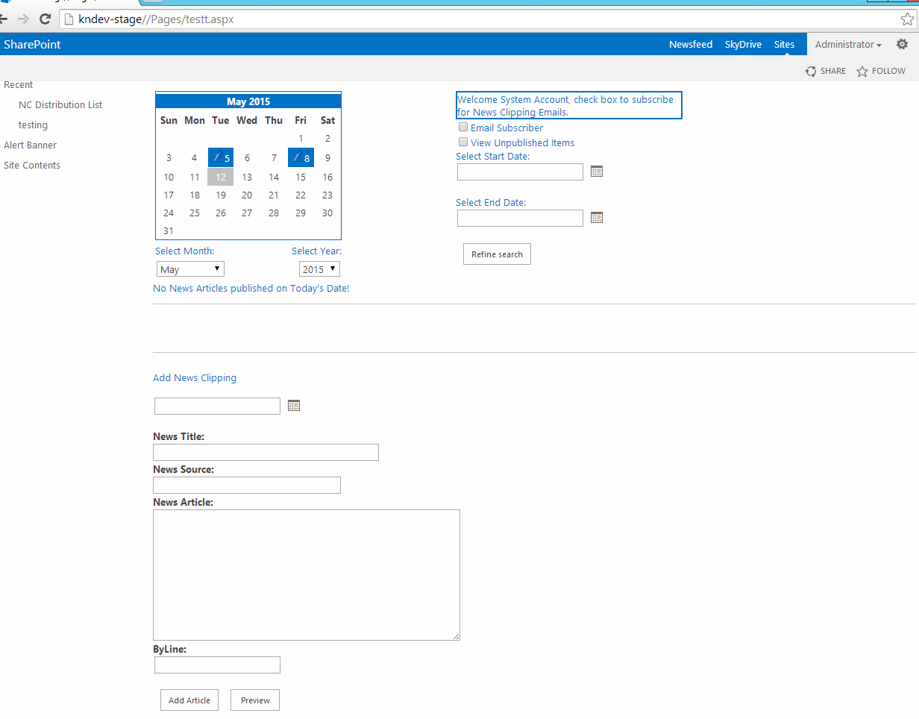

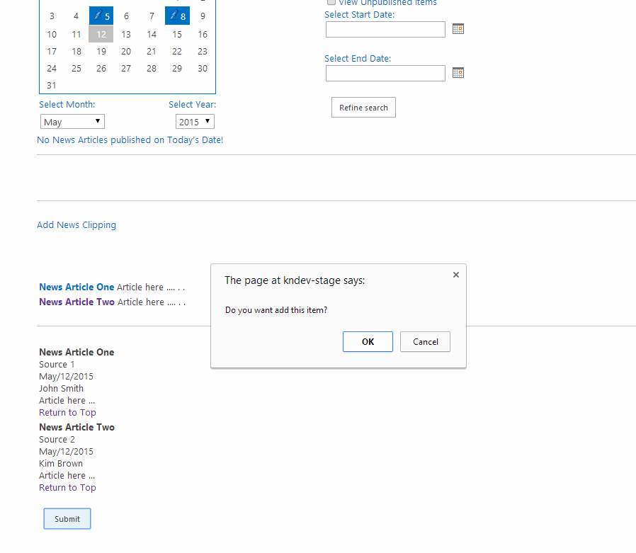

1. **REMOVING NEWS ARTICLE**

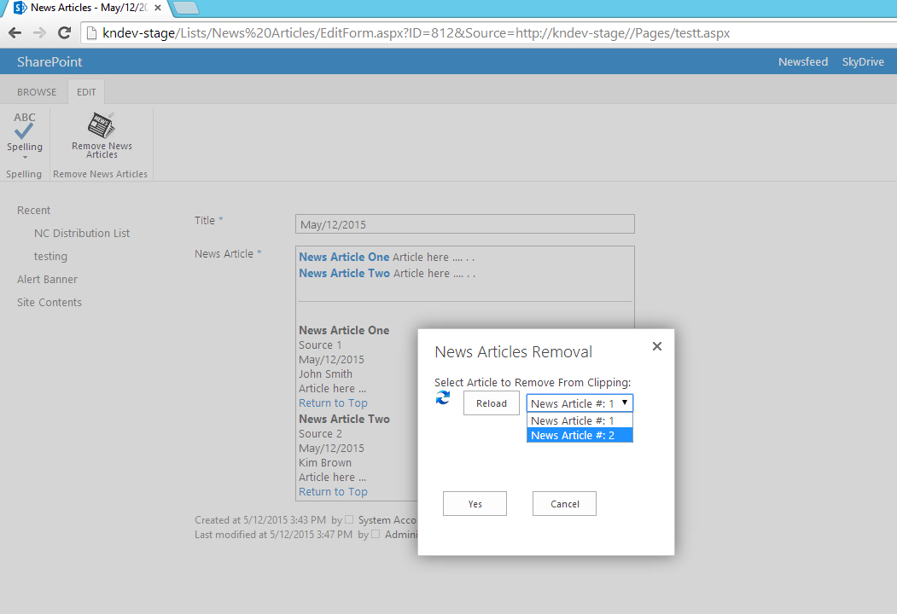

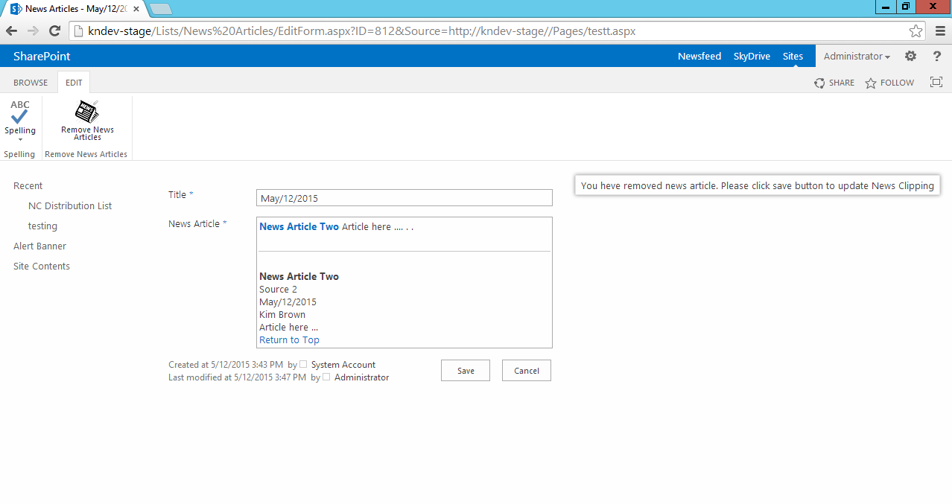

1. **PUBLISHING NEWS CLIPPING**

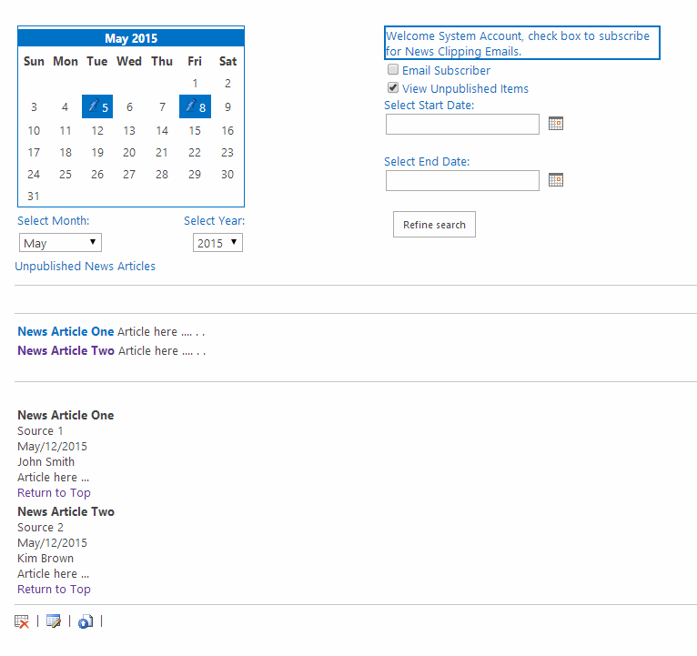

1. **EDITING AND DELETING NEWS CLIPPING**
2. **E-MAIL SUBSCRIBING**

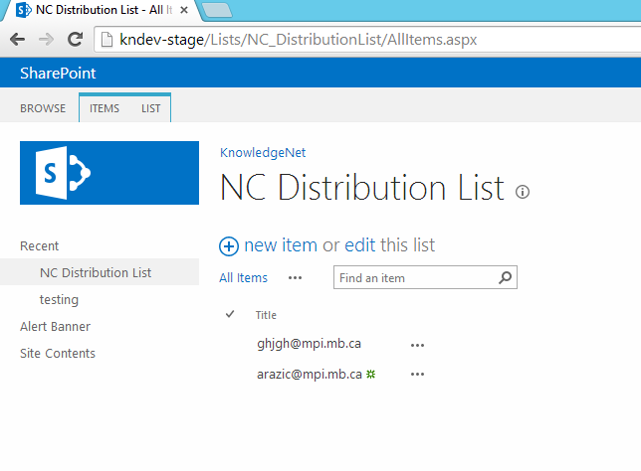

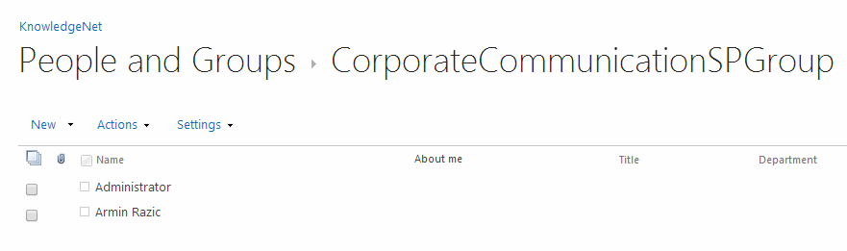

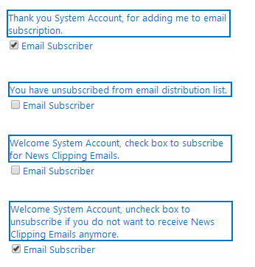

1. **E-Mailing NEWS CLIPPING**

